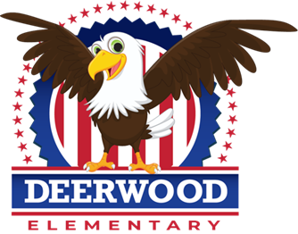
Deerwood Elementary
Prekindergarten Supply List 2021-2022

- Computer Headphones: No earbuds
- Full size backpack (No Wheels please): labeled with child’s name on hook strap. Be sure it is full size, as our projects/folders will not fit in small backpacks! ☺
- Full change of clothes: Each child needs to bring a complete change of clothes (shirt, pants, underwear, socks, and an extra mask in a Ziploc bag labeled with your child’s name) to be left at school.
This year your child will not have a regular supply list because our supplies come from the Orange County Pre-K department. However, there are a few additional items we could use as the children are unable to share supplies this year. If you would like to donate any of the items listed below, we would greatly appreciate it.

Wish List (Optional)

- 24 pack of Crayola Crayons
- Crayola Washable Markers (Broad line- Classic Colors not Bold)
- Elmer’s Glue Bottle (4oz)
- Elmer’s Washable Glue Sticks (3)
- Fiskar Blunt or Rounded Tip Scissors
- Crayola Watercolor Paint Set (8 color oval pan palette)
- Kleenex
- 2 or more Large Packages of Baby Wipes
- 1 ream of white copy paper
- Gallon, Quart, and/or Snack Sized Ziplock Bags
- Large and/or Small Paper Plates
- Small paper or plastic cups (3oz)
- 2 standard solid colored poly 2 pocket folder (no holes or designs please)

The first week of school, I will send home a donation letter asking for a $20 donation per student to help cover the costs of cooking items, special crafts, science activities, class parties, etc.

